Nepal College of Information Technology
Assessment
Fall 2010
Program: ELX/CE/IT Time: 3 hrs
Semester: Fall (III) FM: 100
Subject: Logic Circuits PM: 50

The figures in the margin indicate full marks.
Attempt all the questions:
1 a) Perform the subtraction with the following decimal and binary numbers using 9’s and 1’s complement respectively.
i) 2659-7678(using 9’s complement)
ii) 101101-1101000(using 1’s complement) 5
b) Construct X-NOR gate using minimum number of NAND gates only. 5
c) Show that the dual of X-OR is equal to its complement. 5

2. a) A logic circuit implements the following Boolean function F=A’C+AC’D’
It is found in the circuit that the circuit i/p combination A=C=1 can never occur. Using K-map with proper don’t care conditions, find a simpler expression for F and implement it using NAND gates only assuming that the complemented form of the variable is not available.
8
b) Using K-map Simplify the following Boolean function in POS and SOP form:
F(A,B,C,D)=e(5,7,9,12,13,14,15) &
d(A,B,C,D)=e(3,6,8) 7

3. a) Simplify the following function to minimum no. of literals using Boolean function.
i) (x+y)(x’+z)(y+z)
ii) Xyz+x’y+xyz’ 8
b) Implement the full adder circuit using two 4x1 MUX. 7

4. Design a BCD to seven segment decoder. 15
5. a) Design a code conversion circuit that converts BCD to excess-3 code. 10
b) What are the steps involved in the design procedure of sequential logic circuit. 5
6. a) What are the differences between combinational and sequential logic circuits? Draw the logic diagram and the truth table for R-S flip-flop. 2+4 2+422
b) Realize the following state diagram into the circuit using D-flip-flop. 9
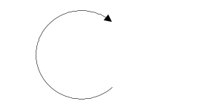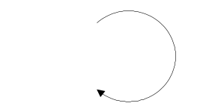
0/0
00
10
1/0
1/0
01
11
1/0
1/1
0/0
0/0
7. Write short notes on (Any Two): 5*2=10
a) Gray Code
b) ROM and its type
c) Digital an Analog systems

